Ecma ek organization company (pura nam European computer manufacturers association) ha jo javascript ka different versions ka auper kam krti ha. Javascript ko invent krny wali company ka nam netscape tha jisny javascript ka sara code 1996 ma ecma non profit organization ko da dia jisky bad javascript ka different versions any lagy jaisy 1997 ma ecma script1 , 1998 ma scmascript2 etc.Major E6 tha jsmy oop concepts bhi introduce kiay gay.

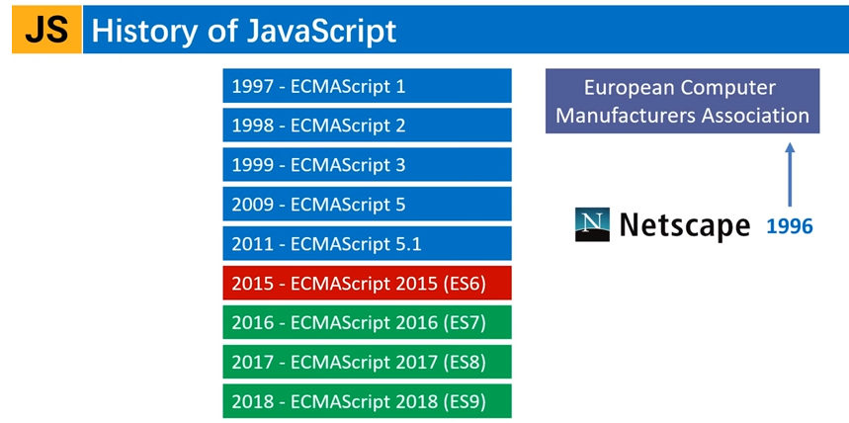

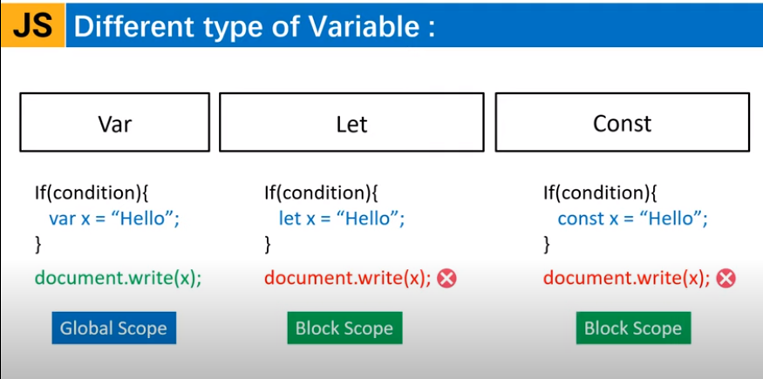

<https://www.javascripttutorial.net/es6/>

**What is Difference between template string and regular string?**

A template literal is just like a better version of a regular JavaScript string. The big difference between a template literal and a regular string is substitutions.

The substitutions allow you to embed variables and expressions in a string. The JavaScript engine will automatically replace these variables and expressions with their values. This feature is known as **string interpolation**.

**What is TDZ?**

~~Wo point jahan sa variable hum access kr rahy hain (hoisted hoty hain) wahan sa la kar wo point jahan variable initialize kia gya ha us drmian ka sara portion tdz kehlata ha.~~ A variable declared by the let keyword has a so-called temporal dead zone (TDZ). The TDZ is the time from the start of the block until the variable declaration is processed.

[https://www.freecodecamp.org/news/javascript-temporal-dead-zone-and-hoisting-explained/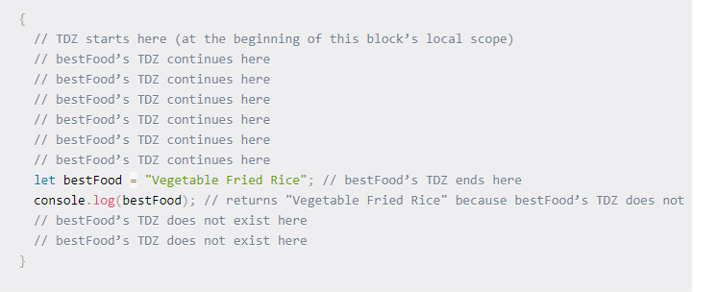](https://www.freecodecamp.org/news/javascript-temporal-dead-zone-and-hoisting-explained/#)

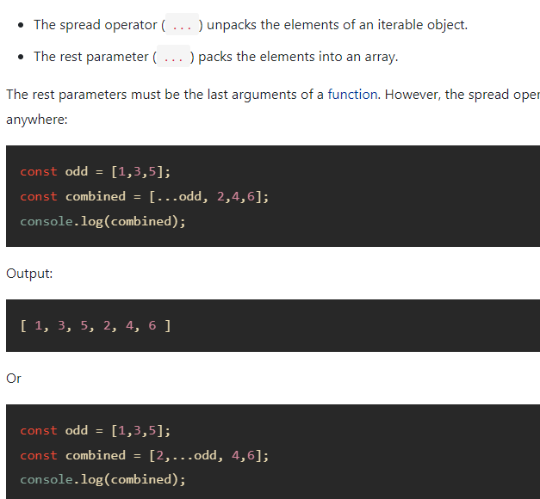

Cloning

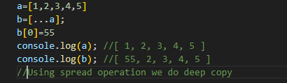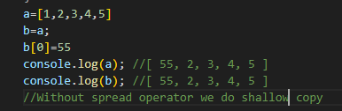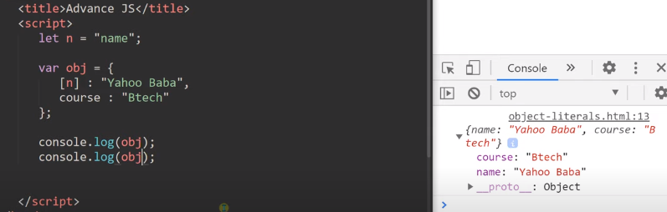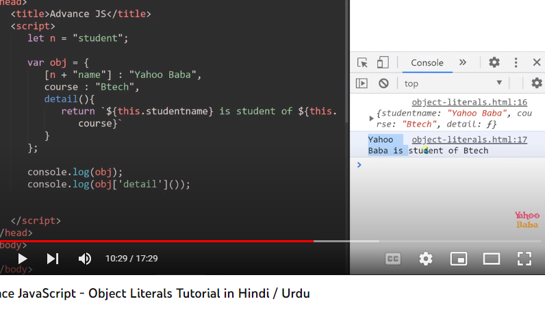

-------------------------------------------------------------------------------------------

ECMAScript is generally used for client-side scripting, and it is also used for writing server applications and services by using [Node.js](https://www.javatpoint.com/nodejs-tutorial). ES6 allows you to write the code in such a way that makes your code more modern and readable. By using ES6 features, we write less and do more, so the term 'Write less, do more' suits ES6.

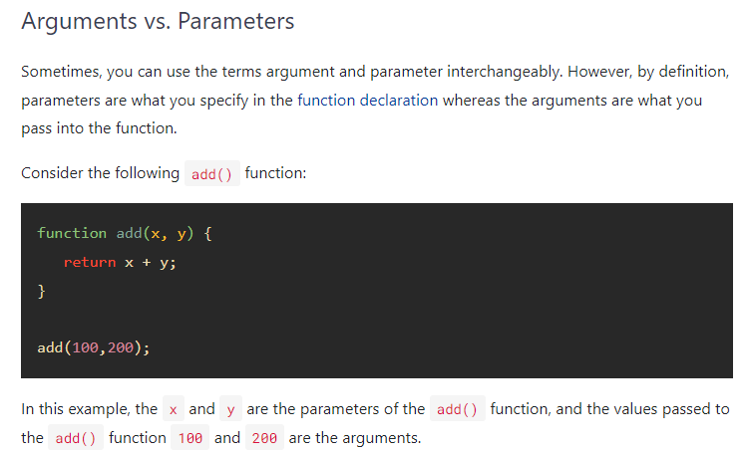

**Literals**

Literals are the numbers,characters,strings etc . **Generally, literals are used for initializing the variables**

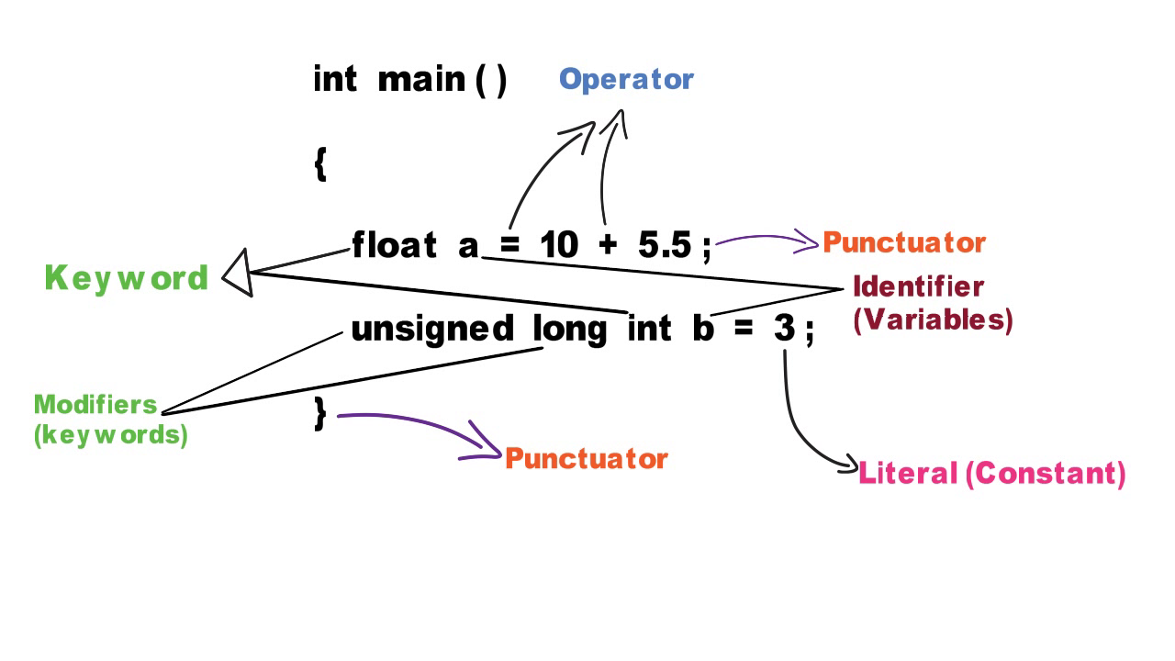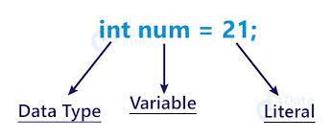

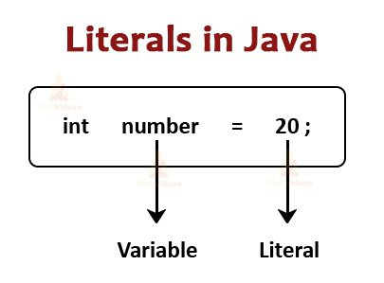

**The Strict Mode**

Sometimes while coding humary code ma buht sa minor errors hoty hain jo ka humain by default show nhi hoty ya wo warnings ma show hoty hain lekin kionky wo errors ma show nhi hoty tu hamain unka malom nahi hota aur bad ma ja kar wo minor errors kafi issues problems create krty hain.Msln

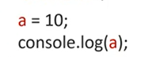

Msln is code ma koi bhi error hamain dekhny pr bazahir nahi show ho raha kionky sb kuch thek ha lekin ismy ek minor error ha aur wo ye ka humny variable a ki data type nahi batai aur bad ma jak kr issue/problem create kr skta ha ye error.is liay agr hum chahty hain ka wo minor errors jo bazahir hamain show nahi ho rahy wo hum dekh sakain tu hamain ‘use strict’ mode use krna ho ga

